CALL FOR SUBMISSIONS:
Community engagement for inclusive rural transformation and gender equality
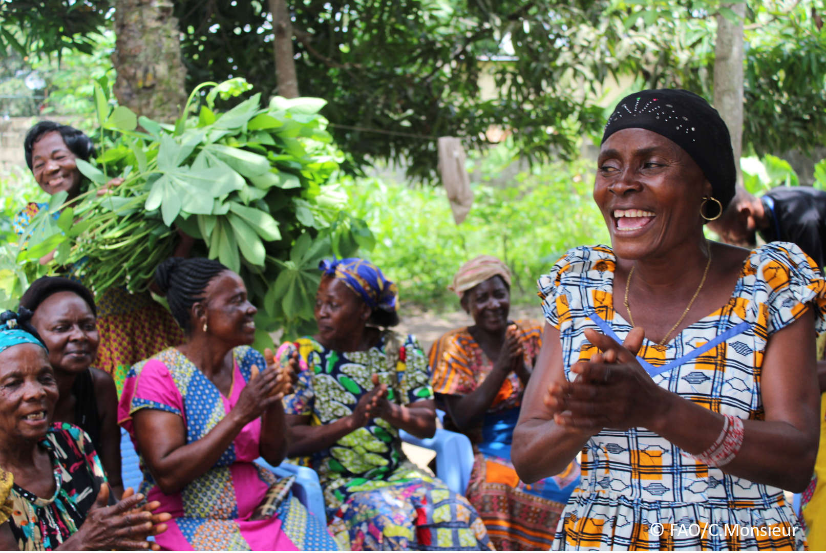
The objective of this call for submissions is to collect good practices, experiences, and lessons learnt on the use of community engagement for inclusive rural transformation and gender equality. The initiative, organized by the Rural Transformation and Gender Equality Division (ESP), seeks to gather insights from a diverse range of contributors, both within FAO and from external stakeholders. Its goal is to share knowledge, foster learning, and guide the scaling up of community engagement and community-led collective action to leave no one behind. The call builds on FAO's past efforts in this area, such as the Community Engagement Days series of webinars.
The call for submissions is open until 27 November 2024.

How to take part in this call for submissions:
To take part in this Call for submissions, please register to the FSN Forum, if you are not yet a member, or “sign in” to your account. Please review the topic note to understand the criteria we are considering for this call. If you wish to learn more about community engagement, you may refer to the background document. Once you have completed this submission template, upload it in the box “Post your contribution” on the call webpage, or, alternatively, send it to fsn-moderator@fao.org.
Please keep the length of submissions limited to 1,500 words and feel also free to attach relevant supporting materials.

Template for submissions

Contact person | Name: Maria Caridad Gonzalez  Organization/Unit: INCA  Country: Cuba  Email address: mcaridad9450@gmail.com
Name/title of the good practice | Participatory selection of Mutant Varieties of Hibiscus in Cuba
Where is the good practice taking place? (Multiple selection allowed) | ☐ Europe and Central Asia  ☒ Latin America and the Caribbean  ☐ North Africa and Near East  ☐ Sub-Saharan Africa  ☐ Asia and the Pacific  ☐ North America  ☐ Global
Affiliation | ☐ Farmer and producer organizations  ☐ Trade Union  ☐ Informal community-based, farmer-based or self-help group  ☒ Research and academia  ☐ Government  ☐ Local/traditional authorities  ☐ Private Sector  ☐ Civil Society Organization  ☐ Intergovernmental Organization (e.g. UN system, World Bank)  ☐ Resource Partner/Donor  ☐ Other (please specify)
In which sector(s) and context (s) have you used this community engagement good practice? (Multiple selections allowed) | ☐ Education  ☐ Health and Sanitation  ☒ Food production in agrifood systems (please also tick the sub-categories)  ☒ Crop cultivation  ☐ Fisheries and aquaculture production  ☐ Livestock  ☐ Forestry  ☐ Agroforestry  ☐ Horticulture  ☐ Apiculture (beekeeping)  ☐ Agroecology and sustainable farming practices  ☐ Soil and water management  ☐ Other: ____________  ☒ Post-production in agrifood systems (please also tick the sub-categories)  ☒ Processing and value addition  ☐ Marketing and retailing  ☐ Transporting  ☐ Food loss and waste  ☐ Packaging  ☐ Storage  ☐ Distribution  ☐ Other _________  ☐ Gender Equality  ☐ Climate Action  ☐ Citizenship and Governance  ☐ Social Protection  ☐ Humanitarian and protracted crisis  ☐ Conflict resolution, peace and resilience  ☐ Digital innovation  ☒ Other sector (please specify) ___Food security______
Who are the financial partners supporting this good practice, if applicable? | National funding as well as international projects (including IAEA TC projects)
- In a few sentences, summarize your community engagement good practice.
This community engages farmers that grow mutant varieties for evaluating together with the breeders at late stages of development in order to provide their opinion on the taste, yield, disease tolerance and other traits. This is called participatory selection, and it contributes to involve the final user of the varieties in the decision of selecting the best lines to be released as new varieties.
- What problem(s) or challenge(s) does your good practice aim to address through community engagement?
Participatory selection of mutant varieties intends to increase acceptability and adoption of new varieties.
- Describe your good practice in more detail. Include the main guiding principles, the desired changes or outcomes you aim to achieve (Theory of Change), and the key phases of implementation.
Initial set of advanced mutant lines identified by the breeder.
Invite farmers to filed days, some of them engaged to test the new lines in their fields.
Evaluation together with the breeder and selection of candidates to be released.
Evaluation of their processing quality to satisfy requirements from entrepreneurs.
Joining all information and final decision to select varieties to be released, and initiate process.
Distribution of seed of new varieties with demand from farmers and entrepreneurs.
- Who are the key actors and stakeholders involved in the design and implementation of the good practice, and what are their respective roles? Consider local partners, government, local authorities, community radios, civil society, research, the private sector, etc.
Main actors are the breeders, entrepreneurs, governmental organizations, research organizations.
- How does your intervention ensure inclusivity and equal and meaningful participation within the community?
Describe how your intervention includes and engages different groups within the community. Consider aspects like gender, age, ethnicity, disability status, livelihoods, and other specific conditions (e.g., people living in prolonged crisis, migrants, refugees). Explain how your intervention engages diverse segments of the rural community. Highlight the specific actions or strategies you use to reach these groups. If applicable, mention if your intervention uses specific approaches such as gender-responsive, gender-transformative, intersectionality, or other methods to ensure inclusivity and gender equality.

Farmers (female and male) are invited to participate in the field days and to plant some of the newly release varieties. Those that agree to participate are involved in the selection process.
As well, entrepreneurs (female and male) that will use the crops for transformation into products such as juices, marmalade, energetic drinks, among others are also involved in the selection and promotion of the varieties.
- By using community engagement, what results and impacts have your good practice achieved?
Please provide specific examples and evidence demonstrating the effectiveness of your intervention, focusing on both qualitative and quantitative outcomes related to livelihoods and well-being improvements.

New varieties released using these methodologies have been rapidly accepted. For example, the introduction of new hibiscus mutant varieties has had a significant socio-economic impact due to the wide range of products derived from hibiscus flowers, including their applications in treating and preventing various diseases. Currently, nearly all hibiscus cultivated in Cuba consists of mutant varieties, accounting for 95% of the acreage.
- Among these results, has the good practice led to improvements in terms of gender equality, women’s empowerment, and/or social inclusion?
Describe the behavioral changes in terms of gender that the good practice promotes, emphasizing agency, leadership, and participation in local governance. Include efforts to challenge discriminatory norms and unequal power dynamics. Highlight also how the intervention has supported the well-being (including psychological resilience) of marginalized groups and enhanced their inclusion and participation in decision-making processes.

The practice described has had improvements in social inclusion as farmers are more aware of the plant breeding efforts conducted at national research institutions and get involved in the process generating a sense of ownership that motivates the utilization of the varieties developed.
- What key challenges did you encounter while implementing the community engagement activities, and how did you address them?
Include any resistance from communities, pushback, or issues related to unequal power dynamics, if applicable.

Challenges are related to get the agreement of farmers to be involved at initial contact and to generate their trust.
- What are the key lesson learned from your community engagement good practice?
Lessons learned are the need to openly share results and accept failure in case divergent points of view from the breeders and farmers.

- Has this practice been replicated in the same context or in different contexts?
What are the required conditions to replicate and adapt the practice in another context/geographical area?
This practice has been replicated for several crops in Cuba
- How sustainable are the results achieved by this good practice?
Describe the key elements that need to be in place to make the initiative sustainable, including enabling environment (legal and policy frameworks and institutions), local ownership, accountability, etc.
The participatory selection is included in the mutation breeding programme for all crops in Cuba.
- Based on the conversations FAO held during the Community Engagement days, a definition of community engagement for empowerment was proposed:

“Community engagement for empowerment and community-led collective action can be defined as an inclusive and participatory process that enables community members to become active agents of change in decisions affecting their lives, health, and environment. This process develops their capacity to achieve sustainable outcomes for improved rural livelihoods. Embracing a rights-based approach, it prioritizes the agency and participation of all community members, regardless of gender identity, sexual orientation, age, ethnicity, caste, socioeconomic status, political affiliation, migration status, or ability/disability. Indeed, inclusive approaches recognize the complexities of overlapping marginalization and discrimination that can exclude different community members from decision-making processes and implement strategies to foster their participation, agency and empowerment.”

We invite you to contribute to this definition. What would you add or change? Please share your thoughts, suggestions, and any additional elements you believe are crucial for a comprehensive understanding of community engagement approaches aimed at community-led collective action for inclusive rural transformation, people’s empowerment and gender equality.

The definition looks adequate
- Based on your experience, what gaps or areas for improvement still need to be addressed in the field of community engagement?
Facilitate access of communities who are geographically located in remote areas.
- What do you think is FAO's role in the field of community engagement? How can FAO support and enhance interventions like yours, if applicable? Consider aspects such as policy advocacy, capacity development, funding, technical assistance, knowledge production and sharing, and fostering partnerships.
The role of FAO, IAEA, and other UN organization is to provide technical assistance and sharing successes to motivate the engagement of new communities.
Link(s) to specific references about your good practice (e.g. reports, communication products, videos, articles)  https://www.iaea.org/newscenter/news/new-crop-varieties-improve-tomato-and-soybean-yields-in-cuba  https://www.fao.org/plant-treaty/areas-of-work/farmers-rights/inventory-on-frs/news-detail/fr/c/810255/ | Please include attachment(s) or add here link(s) to documents/videos/podcasts/other with specific references.

The call for submissions is directly aligned with the thematic components of collective action within FAO's Programme Priority Areas (PPAs), specifically Better Life 1 (Gender Equality and Rural Women’s Empowerment), Better Life 2 (Inclusive Rural Transformation) and Better Life 3 (Agriculture and Food Emergencies).

